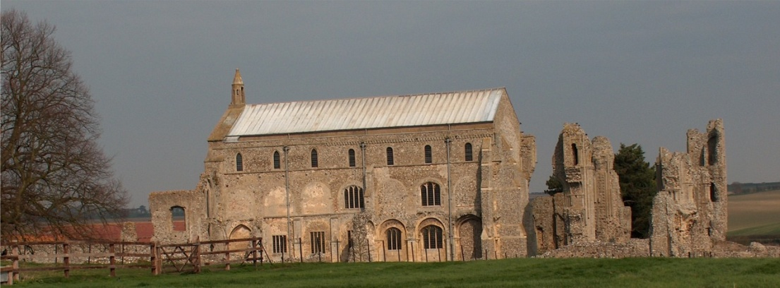
BINHAM WITH COCKTHORPE PARISH COUNCIL
Parish Clerk – Sarah Hayden
53 Cromer Road, Lower Gresham
NR11 8RH
Tel: 01263 570223
Email: sarah352hayden@btinternet.com

Notice & Summons of Parish Council Meeting
Notice is given to the public and Members of the Council are summoned to attend a Meeting of Binham and Cockthorpe Parish Council at the Memorial Hall, Binham
On Monday 10th March 2025 at 7.30pm
S. H. Hayden
Clerk
4th March 2025
The Public are welcome to attend this Parish Council meeting

AGENDA

1. To receive apologies for absence
2. Declarations of Interest and any dispensations of disclosable pecuniary interests
3. Approval of the Minutes of Parish Council Meeting held on 13th January 2025 and 3rd February 2025
4. Matters Arising from those Minutes

5. Reports
5.1 Norfolk County Council
5.2 North Norfolk District Council
5.3 Short report on briefing event by NNDC on the effects of devolution and unitary councils on town and parish councils in Norfolk

6. Planning
6.1 To receive report from Planning Committee
6.2 To discuss and agree observations on any applications after the date of this Agenda and application PF/25/0314 Formation of vehicle access and parking area – Nutwood Farm Bungalow, Binham Road, Wighton, NR23 1NX

7. Finance and Regulatory
7.1 To receive budget against actuals, balance sheet and report on bank reconciliation
7.2 To approve list of payments

8. To discuss funding for new bus shelter including agreement of earmarked reserve

9. Update on 80th anniversary of VE day celebrations and approval of any expenditure

10. Update on cost of path improvement Front Street to The Green

11 Update on repairs to Village Sign and noticeboard

13. Correspondence

14. Items for Information Only or next Agenda

